**A**

**Mini Project Report on**

**FLAME DETECTOR USING AURDINO**

**Submitted by**

**Mr. Gourav Kiran Bidkar (09)**

**Miss. Deepali Pramod Doddabhamannavar (10)**

**Under the Guidance of**

**Mr. A. G. Bhosale**

**For The Award of The Degree of Bachelor of Engineering**

**in**

**Electronics and Telecommunication Engineering**



**DEPARTMENT OF ELECTRONICS AND TELECOMMUNICATION ENGINEERING**

**SOU. SUSHILA DANCHAND GHODAWAT CHARITABLE TRUST’S**

**SANJAY GHODAWAT GROUP OF INSTITUTIONS, ATIGRE 2019-2020**

DEPARTMENT OF ELECTRONICS AND TELECOMMUNICATION

ENGINEERING

SOU. SUSHILA DANCHAND GHODAWAT CHARITABLE TRUST’S

SANJAY GHODAWAT GROUP OF INSTITUTIONS, ATIGRE



CERTIFICATE

This is to certify that, the mini project report entitled “”

Submitted by

**Mr. Gaurav Kiran Bidkar (09)**

**Miss. Deepali Pramod Doddabhamannavar (10)**

in the partial fulfillment for the award of the Degree of Bachelor of Engineering

in

Electronics and Telecommunication Engineering

is a record of student’s own work carried out by him under my supervision

and guidance during the academic year **2019-2020**

(Mr. A. G. Bhosale) (N.B.Bahadure)

Guide HOD E&TC Dept.

**CONTENTS**

**Chapter Page no.**

1. **Introduction** 1
2. 1.1 Overview 2

1.2 Objective of Project

**2 Literature Review** 3 4

**3 PCB Design** 4

3.1Types of PCB 5

3.4 Advantages of PCB 5

**4 Project Design**

4.1 Block Diagram and Description 6

4.2Circuit Diagram 7

4.3 Working 8

**5 Component Description**

5.1 Component List 10

5.2 Component Description 11

**6 Software Flowchart**

6.1 Program Flowchart 13

6.1.1 Main Program 14

**7 Applications**  16

**8 Conclusion and Future Scope**

8.1 Result 17

8.2 Conclusion 17

**9 References**

9.1 Websites 18

# Chapter 1

# INTRODUCTION

A flame detector system has a number of devices working together to detect and warn people through visual and audio appliances when smoke, fire, carbon monoxide or other emergencies are present. These alarms may be activated automatically from smoke detectors, and heat detectors or may also be activated via manual flame detector activation devices such as manual call points or pull stations. Alarms can be either motorized bells or wall mountable sounders or horns. They can also be speaker strobes which sound an alarm, followed by a voice evacuation message which warns people inside the building not to use the elevators. Flame detector sounders can be set to certain frequencies and different tones including low, medium and high, depending on the country and manufacturer of the device. Most flame detector systems in Europe sound like a siren with alternating frequencies. Flame detector electronic devices are known as horns in the United States and Canada, and can be either continuous or set to different codes. Flame detector warning devices can also be set to different volume levels.

## Overview

In this project we are using an IR based flame sensor. It is based on the YG1006 sensor which is a high speed and high sensitive NPN silicon phototransistor. It can detect infrared light with a wavelength ranging from 700nm to 1000nm and its detection angle is about 60°. Flame sensor module consists of a photodiode (IR receiver), resistor, capacitor, potentiometer, and LM393 comparator in an integrated circuit. The sensitivity can be adjusted by varying the on board potentiometer. Working voltage is between 3.3v and 5v DC, with a digital output. Logic high on the output indicates presence of flame or fire. Logic low on output indicates absence of flame or fire.

## OBJECTIVE OF PROJECT

The main **objective** of most **fire detection** and **alarm** signaling systems is detecting a **fire** early so as to initiate various actions. ... In addition, over the last several revision cycles, efforts have been made to help better address **detection** systems in the performance-based analysis and design process.

**Chapter 2**

**LITERATURE REVIEW**

**Literature Review Flame detector** The addressable **flame detector system** comprises one or more circuits with **detectors** connected in parallel, and each **detector** has a unique identification (address) on the circuit. In an addressable **system**, each **detector** has the ability to identify itself and its current status.

# Chapter 3

# PCB DESIGN

## ADVANTAGES OF PCB

Printed circuit is of interest to industry because

1. They are the common denominator for almost all approaches to mechanized fabrication of electronics equipment.

2. Here use has gristly reduced the labor required for the wiring of an electronic circuit. This reduction is especially significant for small units in computer & guided-missile equipment.

3. Their uniformity improves the product through simplification of quality control and boards with greater density are charged more.

**Chapter 4**

# PROJECT DESIGN

**4.1 BLOCK DIAGRAM AND DESCRIPTION:**

## 

## Fig4.1 Block diagram of flame detector with arduino

**DESCRIPTION**

**Flame Sensor :**

A flame detector is a sensor designed to detect and respond to the presence of a flame or fire. Responses to a detected flame depend on the installation, but can include sounding an alarm, deactivating a fuel line (such as a propane or a natural gas line), and activating a fire suppression system.

There are different types of flame detection methods.

Some of them are: Ultraviolet detector, near IR array detector, infrared (IR) detector, Infrared thermal cameras, UV/IR detector etc.

**Buzzer :**

A buzzer or beeper is an audio signaling device, which may be mechanical, electromechanical, or piezoelectric (piezo for short). Typical uses of buzzers and beepers include alarm devices, timers, and confirmation of user input such as a mouse click or keystroke.

**LCD:**

An LCD is an electronic display module which uses liquid crystal to produce a visible image. The 16*2 LCD is a very basic module commonly used inDIYs and circuits. The 16*2 translates a display 16 characters per line in 2 such lines. In this LCD each character is displayed in 5*7 pixel matrix.

**Arduino Uno :**

Arduino Uno is a microcontroller board based on the ATmega328P (datasheet). It has 14 digital input/output pins (of which 6 can be used as PWM outputs), 6 analog inputs, a 16 MHz ceramic resonator (CSTCE16M0V53-R0), a USB connection, a power jack, an ICSP header and a reset button.

### CIRCUIT DIAGRAM

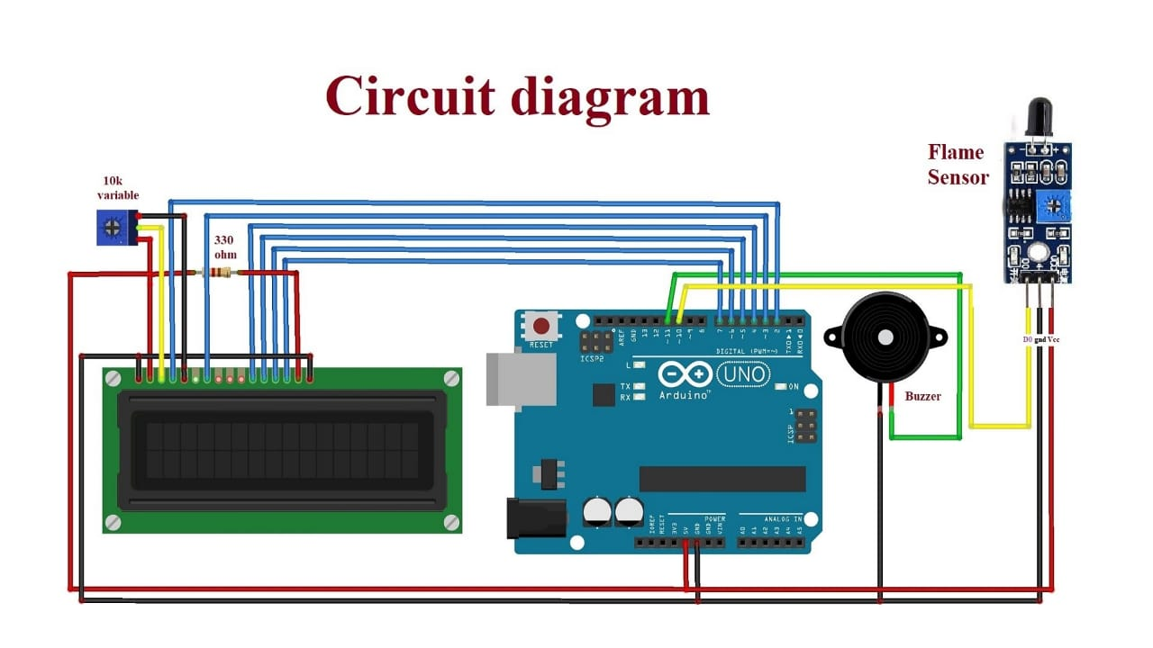

**Fig 4.2 Circuit diagram of flame detector**

### WORKING

Arduino Uno is a open source microcontroller board based on ATmega328p microcontroller. It has 14 digital pins (out of which 6 pins can be used as PWM outputs), 6 analog inputs, on board voltage regulators etc. Arduino Uno has 32KB of flash memory, 2KB of SRAM and 1KB of EEPROM. It operates at the clock frequency of 16MHz. Arduino Uno supports Serial, I2C, SPI communication for communicating with other devices. The table below shows the technical specification of Arduino Uno.

|  |  |
| --- | --- |
| Microcontroller | ATmega328p |
| Operating voltage | 5V |
| Input Voltage | 7-12V |
| Digital I/O pins | 14 |
| Analog pins | 6 |
| Flash memory | 32KB |
| SRAM | 2KB |
| EEPROM | 1KB |
| Clock speed | 16MHZ |

The flame sensor detects the presence of fire or flame based on the Infrared (IR) wavelength emitted by the flame. It gives logic 1 as output if flame is detected, otherwise it gives logic 0 as output. Arduino Uno checks the logic level on the output pin of the sensor and performs further tasks such as activating the buzzer and LED, sending an alert message

**Chapter 5**

# COMPONENT DESCRIPTION

## COMPONENT LIST

|  |  |
| --- | --- |
| Arduino Uno  (any Arduino board can be used) | ATmega328P |
| Flame sensor | 760nm - 1100nm |
| Buzzer | 6V |
| Resistor | 330ohm |
| LED | 5mm |
| Jumper wires | 20cm |
| LCD Display | HD44780 16*2 |

## COMPONENT DESCRIPTION:

**Arduino Uno** :

**Arduino Uno** is a microcontroller board based on the ATmega328P (datasheet). It has 14 digital input/output pins (of which 6 can be used as PWM outputs), 6 analog inputs, a 16 MHz ceramic resonator (CSTCE16M0V53-R0), a USB connection, a power jack, an ICSP header and a reset button.

**Flame Sensor:**

A flame detector is a sensor designed to detect and respond to the presence of a flame or fire. Responses to a detected flame depend on the installation, but can include sounding an alarm, deactivating a fuel line (such as a propane or a natural gas line), and activating a fire suppression system.

There are different types of flame detection methods.

Some of them are: Ultraviolet detector, near IR array detector, infrared (IR) detector, Infrared thermal cameras, UV/IR detector etc.

 **buzzer :**

A **buzzer** or beeper is an audio signaling device, which may be mechanical, electromechanical, or piezoelectric (piezo for short). Typical uses of **buzzers** and beepers include alarm devices, timers, and confirmation of user input such as a mouse click or keystroke.

**Resistor :** for controlling the voltage

**Led :** as a light source( 5 MM)

**Jumper Wires:**

Jumper wire is an electrical wire, or group of them in a cable, with a connector or pin at each end which is normally used to interconnect the components of a breadboard or other prototype or test circuit, internally or with other equipment or components, without soldering.

**LCD:**

An LCD is an electronic display module which uses liquid crystal to produce a visible image. The 16*2 LCD is a very basic module commonly used inDIYs and circuits. The 16*2 translates a display 16 characters per line in 2 such lines. In this LCD each character is displayed in 5*7 pixel matrix.

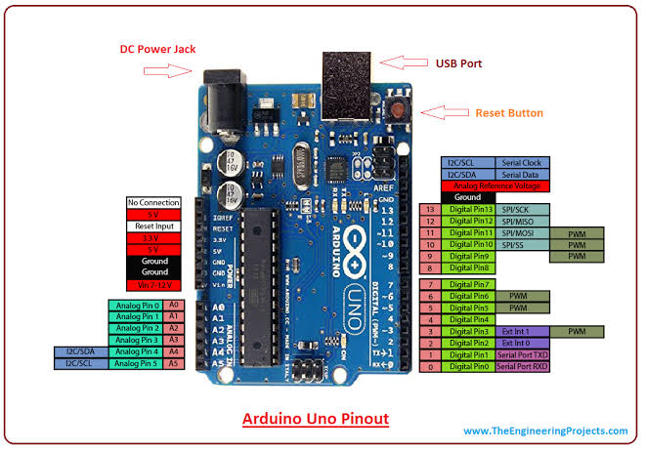

**Fig 5.2 Pin diagram of Arduino uno**

**Chapter 6**

# 6.1.1 Program

#include <LiquidCrystal.h>

LiquidCrystal lcd(2, 3, 4, 5, 6, 7);

#define flamePin 10

#define buzzerPin 11

void setup() {

Serial.begin(9600);

lcd.begin(16, 2);

pinMode(buzzerPin,OUTPUT);

pinMode(flamePin,INPUT);

lcd.setCursor(0, 0);

lcd.print("Calibrating");

for(int i = 0; i <15; i++){

if (i==4)

{

lcd.setCursor(0, 1);

lcd.print(".");

}

else lcd.print(".");

delay(500);

}

lcd.setCursor(11, 1);

lcd.print("Done");

delay(1000);

lcd.clear();

lcd.setCursor(1, 0);

lcd.print("Sensor Active");

delay(1500);

lcd.clear();

}

void loop() {

int Flame = digitalRead(flamePin);

if (Flame == LOW)

{

digitalWrite(buzzerPin,HIGH);

lcd.setCursor(0, 0);

lcd.print(" Flame : ");

lcd.print("Flame");

lcd.setCursor(0, 1);

lcd.print(" is Detected");

Serial.print(Flame);

Serial.print("\t");

Serial.print("Flame is Detected");

}

else if (Flame == HIGH)

{

digitalWrite(buzzerPin,LOW);

lcd.setCursor(0, 0);

lcd.print("Flame : ");

lcd.print("No Flame");

Serial.print(Flame);

Serial.print("\t");

Serial.println("No Flame");

}

delay(300);

lcd.clear();

}

# Chapter 7

# APPLICATIONS

1] Used in all manufacturing industries

2] Can used in hospitals

3] Home Security System

4] School/college labs

5] R&D Cell

# Chapter 8

# CONCLUSION AND FUTURE SCOPE

**FUTURE SCOPE:**

1] Fire accidents can be controlled to a great extent in a places such as forests, homes, colleges industries, trains and some other public places.

2]Fire accidents leads to death of excess of people, by using this technique we can save those life easily

3]To detect the chain smokers (which are hazardous to health)

**Conclusion:-**

1] Fire is a good master and a bad slave, so we should handle carefully and safely.

2] Our system provides protection against dangerous fire accident and there by protecting human life.

**Chapter 9**

**REFRENCES**

**10.1 Websites**

http://[www.1000projects.com](http://www.1000projects.com)

<http://www.alldatasheets.com>

<http://www.webopedia.com/TERM/L/LCD.html>